BioLink Database Utilities
BioLink Database Utilities 1
Creating a new database 1
Backing up an existing database 2
Restoring a database from a backup 3
Creating a New Database during a Restore 3
Replacing an Existing Database during a Restore 3
Detaching and Attaching Databases 4
Detaching a Database 4
Attaching a Database 4
Upgrading a database 4
Deleting a database 5
Shrinking a database and truncating a log file 5
Viewing properties of a database 5
Updating Site, Site Visit and Material Names 6

BioLink Database Utilities
The BioLink Database Utilities program assists with the administration of Biolink databases (using both MSDE 2000 and SQLServer 2000). The program provides tools for the following tasks.
- Creating new databases
- Backing up existing databases
- Restoring databases from backup copies
- Detaching and attaching databases
- Upgrading an existing database
- Deleting databases
- Shrinking databases and truncating log files
- Viewing properties of databases
To open the Database Utilities window press the Start button on the Windows Task Bar, select Programs, then BioLink and finally DBUtils. This will open the BioLink Database Utilities program.

Creating a new database
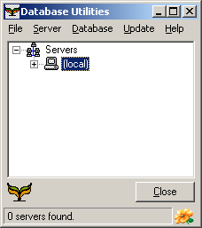
To create a new BioLink database follow these steps:
- Select the server where the database is to be created from the list in the Database Utilities window and select the Logon command from the Server menu. Log on to the server by entering a username and password and pressing the OK button.
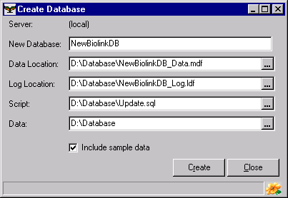
- Select the Create Database command from the Server menu. This will open the Create window.
- Enter a name for the new database in the New Database field and the name and location of the database file and log file in the Data Location and Log Location fields.
- To create a database you will need a database script (containing SQL statements which define the database structure) and bulk copy files (.bcp) (which contain essential information used internally by BioLink, and optionally, additional data). These can both be found on the Biolink CD-ROM. Enter the path and file name for the script file in the Script field and the path to the directory containing the bulk copy files in the Data field. If using the BioLink CD-ROM, the Script field will be X:\DatabaseScripts\update.sql and the Data field will be X:\DatabaseScripts\BCPData, where X: is the letter of the CD drive containing the BioLink CD.
- If the bulk copy files contain non-essential data and this is to be loaded make sure the Include Sample Data box is checked.
- Press the Create button to create the new database (this will take a few minutes).
- When complete, close the Create Database window and exit the Database Utilities program.
To access this new database, start BioLink and create a new Source Profile pointing to the newly created database (use an existing Source as a model, modifying the Database Name field to contain the name of the newly created database).

Backing up an existing database
- Select the server containing the database to be backed up from the list in the Database Utilities window and select the Logon command from the Server menu. Logon to the server by entering a username and password and pressing the OK button.
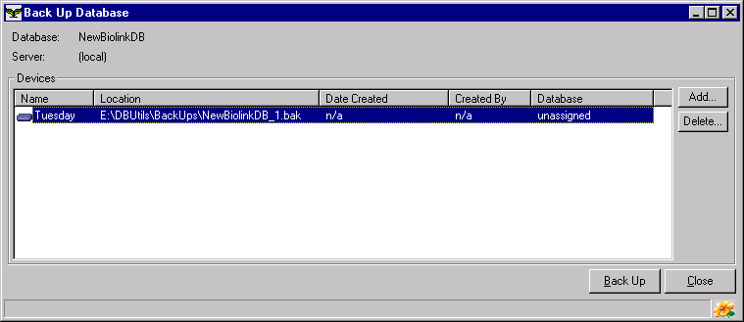
- The name(s) of the BioLink databases present on the selected server will be listed under the server’s name in the list. Select the database to backup followed by the Back Up command from the Database menu. This will open the Back Up Database window.
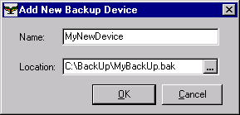
- Backups are done to ‘devices’. A device is essentially a file. To create a new device, press the Add button. This will open the Add New Backup Device window. Enter the name of the device and its path and file name and press the OK button. This will create the new device and add it to the Backup Database window. To use an existing device, select it in the list in the Backup Database window. To delete a device which is no longer needed, select it in the list and press the Delete button.
- Once a device has been created, make sure it is selected in the list and press the Back Up button. If an existing device is being used you will be prompted to overwrite it. The selected database will be backed up to the chosen device.
- When complete close the Upgrade window and exit Database Utilities.

Restoring a database from a backup
There are two ways to restore a database from a backup. The first way is to create a new database during the restore process and the other is to replace an existing database with its backup. Instructions for these two methods are as follows.

Creating a New Database during a Restore
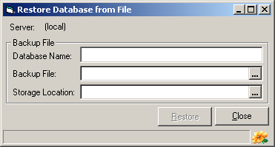
- Select the server to restore to from the list in the Database Utilities window and select the Logon command from the Server menu. Logon to the server by entering a username and password and pressing the OK button.
- With the server selected, select the Restore command from the Database menu. This will open the Restore Database from File window.
- Enter a name for the new database along with the name (including path) of the backup file and the location where the database is to be created.
- Once this information is complete press the Restore button. The database will then be created in the specified locality.

Replacing an Existing Database during a Restore
- Select the server to restore to from the list in the Database Utilities window and select the Logon command from the Server menu. Logon to the server by entering a username and password and pressing the OK button.
- The name(s) of the BioLink databases present on the selected server will be listed under the server’s name in the list. Select the database to restore followed by the Restore command from the Database menu. This will open the Restore Database window. Backups of the selected database will be listed. Their storage location, date created and person who created them will also be shown.
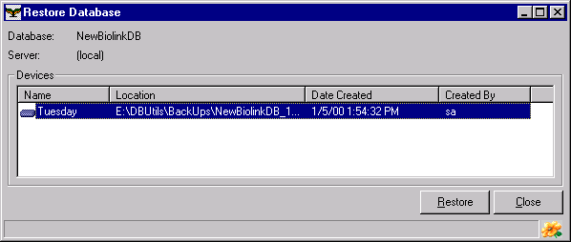
- To restore (and overwrite) the selected database with information from the backup, select the desired backup from the list and press Restore. When prompted press Yes to overwrite the existing database and replace it with the contents of the selected backup.

Detaching and Attaching Databases
BioLink databases are files that are managed by SQLServer. SQLServer stores information about these files internally and when it’s running these files cannot be accessed. (When SQLServer is stopped – using the Service Manager– these files are accessible but they cannot be moved or SQLServer will “lose track” of them.) To backup or move database files they must be “detached” from SQLServer. Once detached they can be treated as a normal file although they will not be accessible by SQLServer and therefore will not be available to BioLink. To make them available again hey must be “attached” to SQLServer again.

Detaching a Database
To detach a database, follow these instructions.
- Select the server to restore to from the list in the Database Utilities window and select the Logon command from the Server menu. Logon to the server by entering a username and password and pressing the OK button.
- The name(s) of the BioLink databases present on the selected server will be listed under the server’s name in the list. Select the database to detach followed by the Detach command from the Database menu.
- A window will open showing the current location of the database and log files. Press the Detach button to detach the database or the Close button to leave the database attached.

Attaching a Database
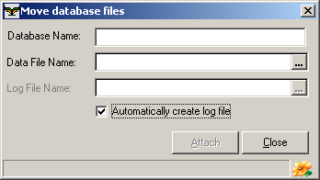
- Select the server to attach the database to from the list in the Database Utilities window and select the Logon command from the Server menu. Logon to the server by entering a username and password and pressing the OK button.
- With the server selected, select the Attach command from the Database menu. This will open the Attach Database window.
- Enter a name for the attached database along with the name (including path) of the detached file.
- Once this information is complete press the Attach button. The file will then be attached and will be available to SQLServer and BioLink.

Upgrading a database
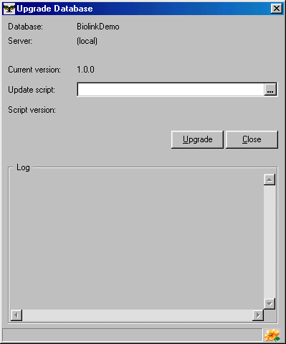
- Select the server containing the database to be upgraded from the list in the Database Utilities window and select the Logon command from the Server menu. Logon to the server by entering a username and password and pressing the OK button.
- The name(s) of the BioLink databases present on the selected server will be listed under the server’s name in the list. Select the database to upgrade followed by the Upgrade command from the Database menu. This will open the Upgrade window.
- Enter the name of the file containing the upgrade script. Click the Ellipsis button (with the three dots) to the right of the Update Script field to open the Open File dialog. If upgrading from the BioLink CD, navigate to the file named update.sql in the DatabaseScripts directory. Select this file and press OK to return to the Upgrade Database window.
- Press the Upgrade button to upgrade the database (this will take a few minutes).

Deleting a database
- Select the server containing the database to delete from the list in the Database Utilities window and select the Logon command from the Server menu. Logon to the server by entering a username and password and pressing the OK button.
- The name(s) of the BioLink databases present on the selected server will be listed under the server’s name in the list. Select the database to delete followed by the Delete command from the Database menu.
- Press the Yes button to confirm the permanent deletion of the database, or the No button to abort and leave the database in place.

Shrinking a database and truncating a log file
- Select the server containing the database to shrink or whose log is to be truncated from the list in the Database Utilities window and select the Logon command from the Server menu. Logon to the server by entering a username and password and pressing the OK button.
- The name(s) of the BioLink databases present on the selected server will be listed under the server’s name in the list. Select the required database followed by either the Shrink or Truncate Log commands from the Database menu.
- Press the Yes button to confirm the shrinking database, or the No button to abort the command. If truncating the log, no prompt will be given before the log file is truncated.

Viewing properties of a database
- Select the server containing the database of interest from the list in the Database Utilities window and select the Logon command from the Server menu. Logon to the server by entering a username and password and pressing the OK button.
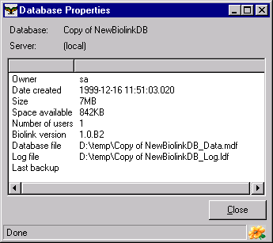
- The name(s) of the BioLink databases present on the selected server will be listed under the server’s name in the list. Select the required database followed by the Properties command from the Database menu. A window will open displaying selected properties for the selected database.

Updating Site, Site Visit and Material Names
The names for Sites, Site Visits and Material are created automatically by the Rapid Data Entry window and manually using the Site Detail, Site Visit Detail and Material Detail windows. However, using these windows only changes one record at a time. There may be times when these names need to be changed across the entire database. This can be done as follows.
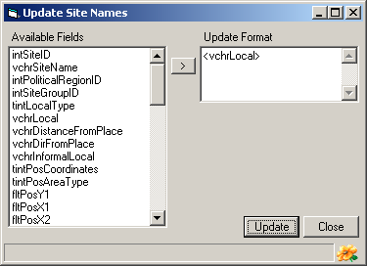
- Log onto the server containing the database to be modified and then select the database. Open the Update menu and select either the Site Names, Site Visit Names or Material Names command. This will open the requested Update Names window.
- The Available Fields list on the left side of the window contains a list of all fields relating to Sites, Site Visits or Material. Select the required field and press the > button to transfer it to the Update Format text box on the right of the window.
- Add text around the database field names in the Update Format text box. When the update is run the field names will be replace with values from the database while plain text will be inserted unchanged. For example, to update the Material name to accession number and taxon name separated by a colon, first transfer the two database fields vchrAccessionNo and intBiotaID. The Update Format text box will then contain “<vchrAccessionNo><intBiotaID>”. Now add a colon and space between these fields, Update Format then containing “<vchrAccessionNo>: <intBiotaID>”. When run, the Material name in the database will be updated with text such as “32-000483: Camponotus gasseri”.
- When the Update Format has been specified press the Update button to run the update. The status bar at the bottom of the window will indicate the record being updated along with the total number of records to be updated.

